1. Create a pipeline name 'Without_Foreach_Example' to copy the Customer & Customer address table data into ADLS without using foreach activity.

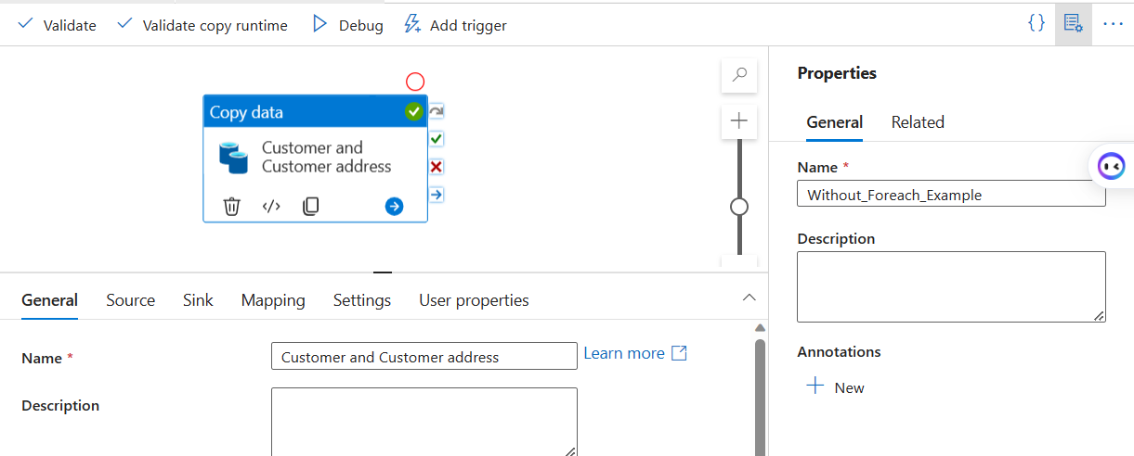

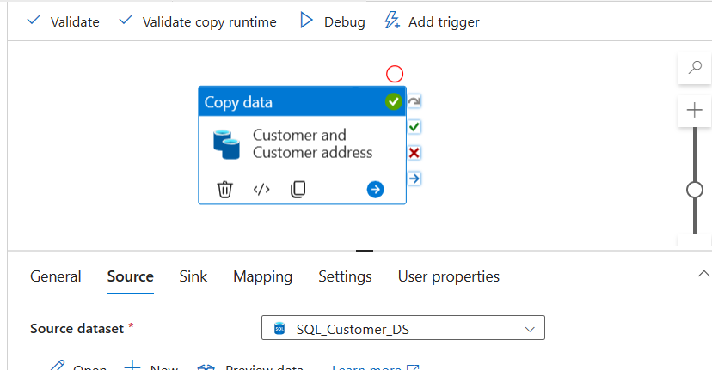

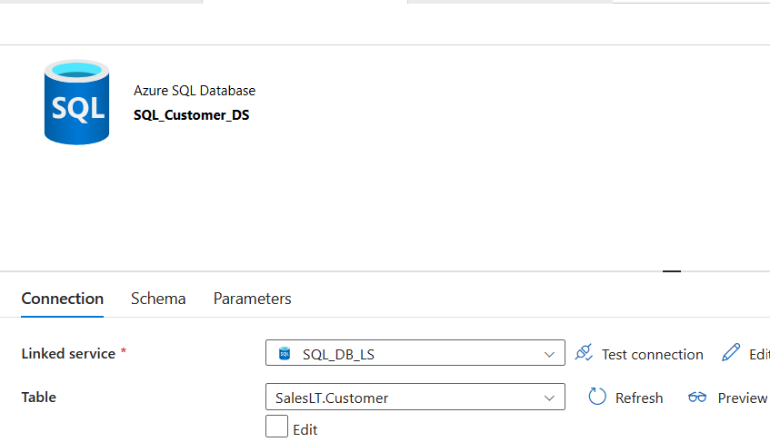

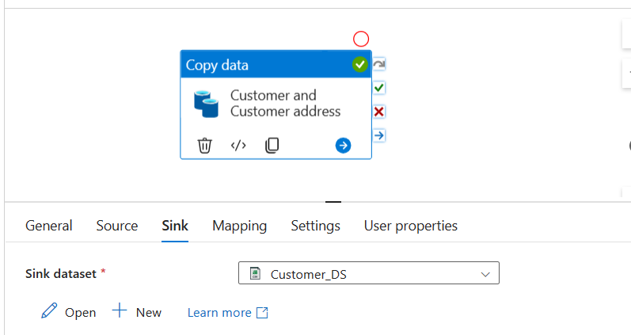

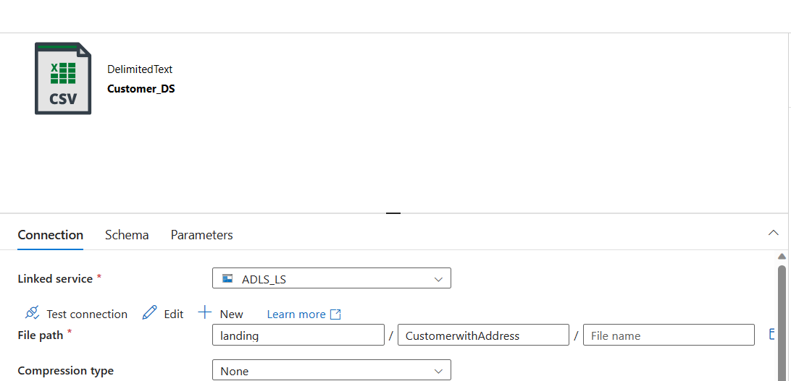

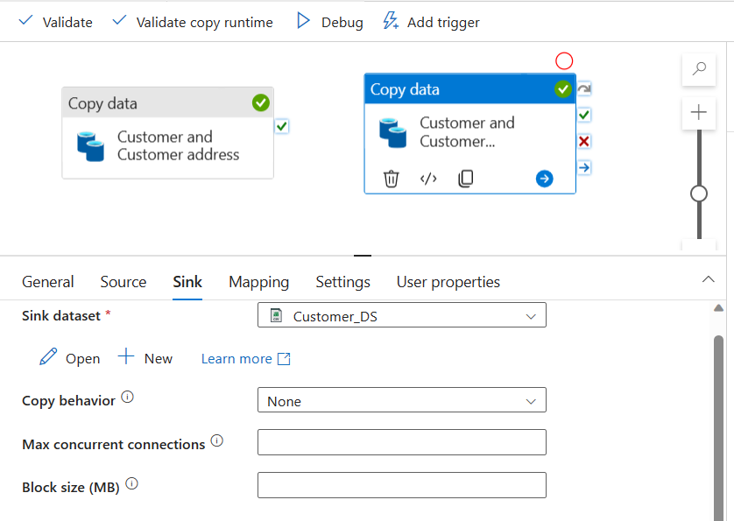

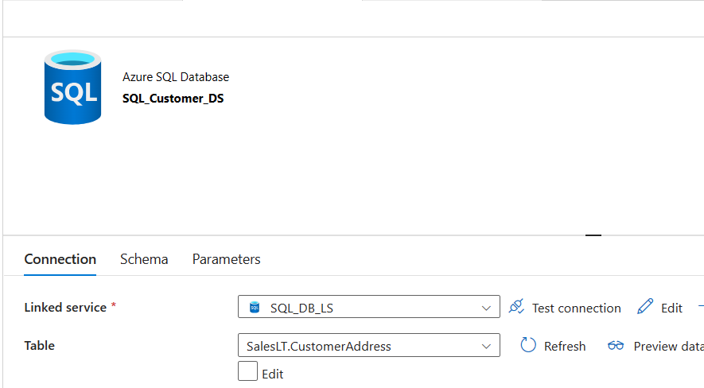

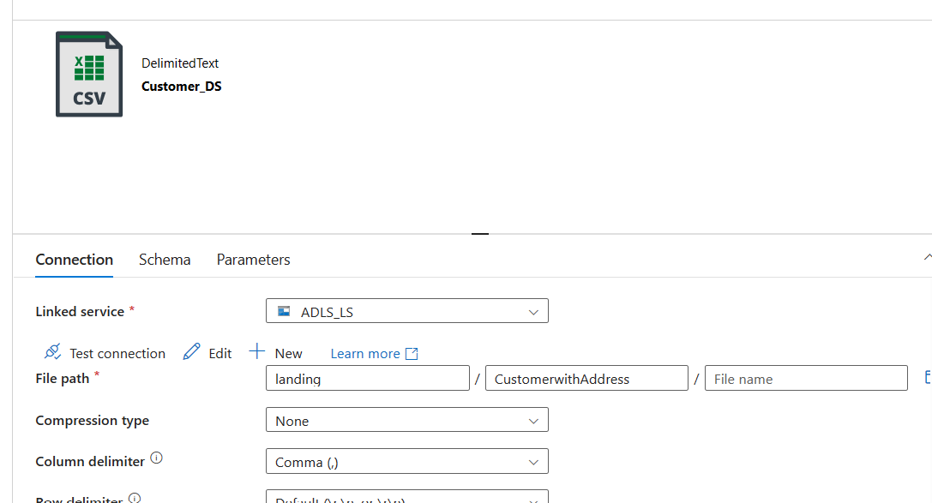

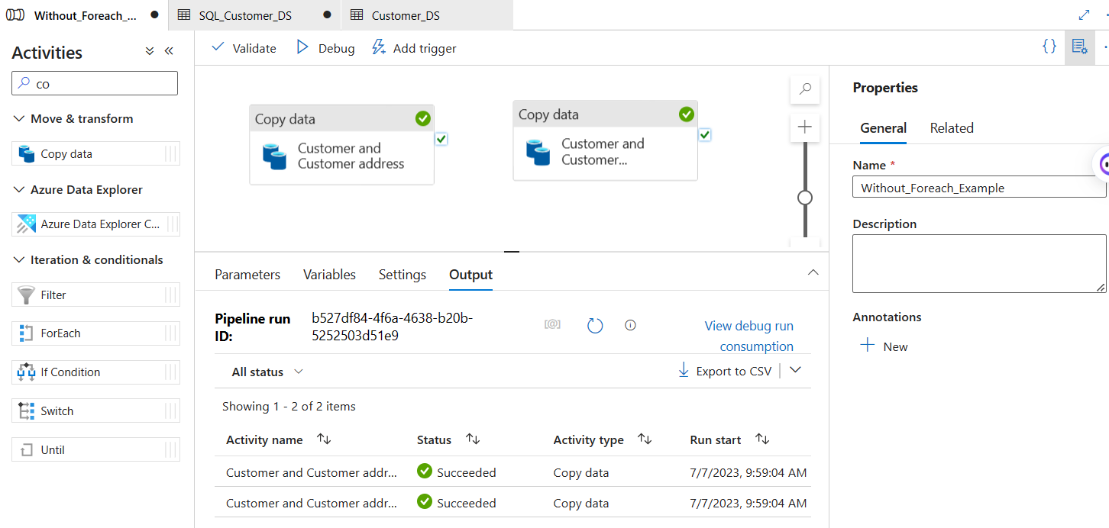

2. Create a pipeline name 'Foreach_Example' to copy the Customer & Customer address table data into ADLS using the one copy activity.

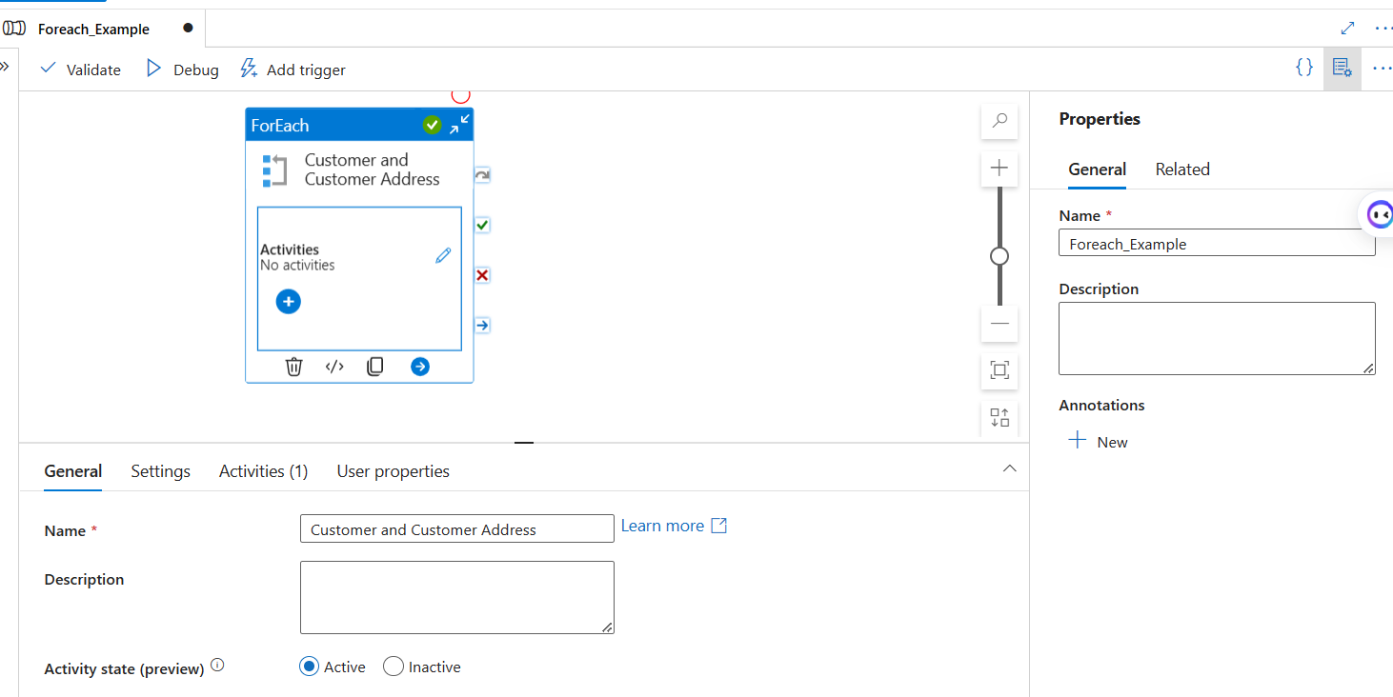

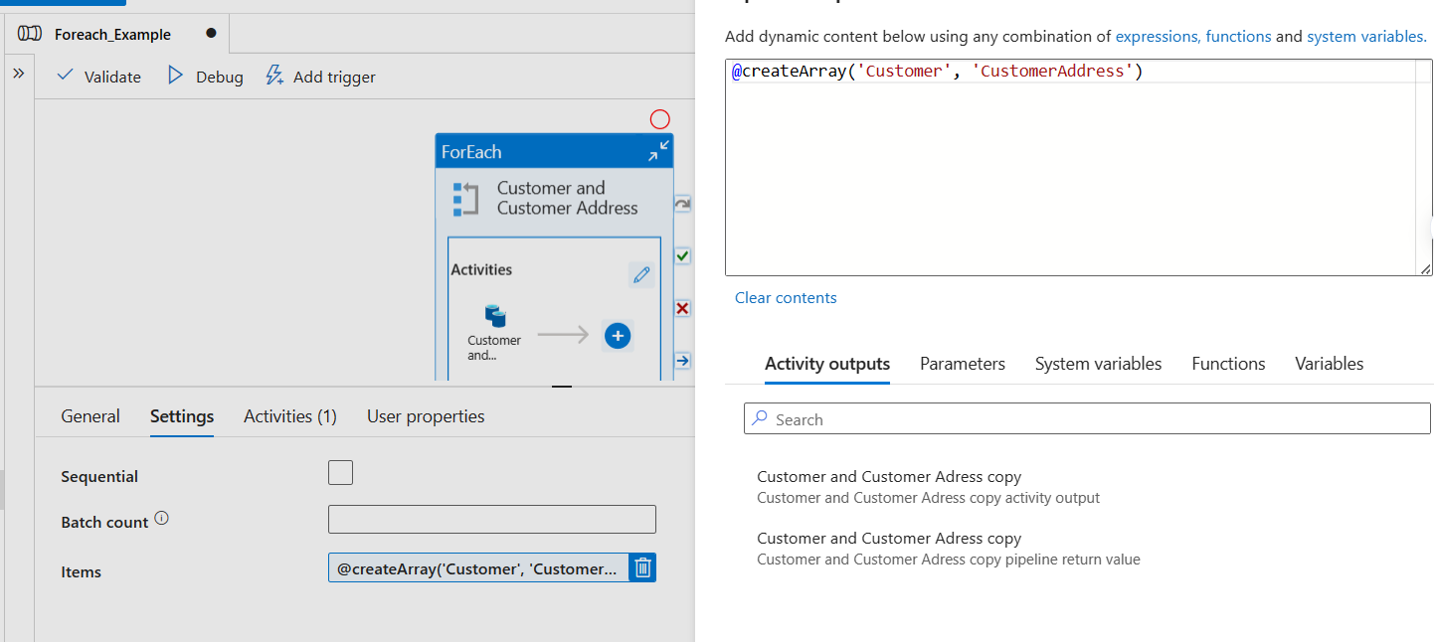

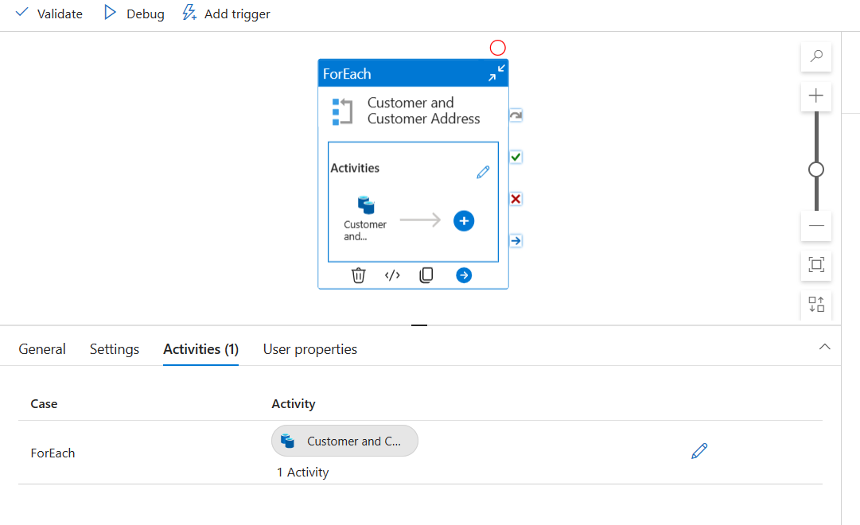

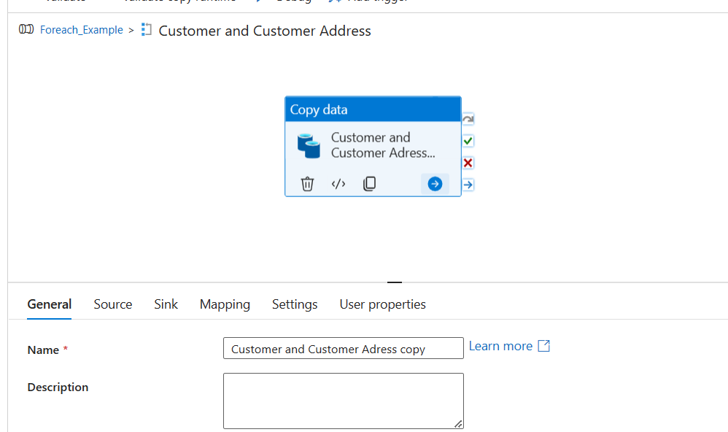

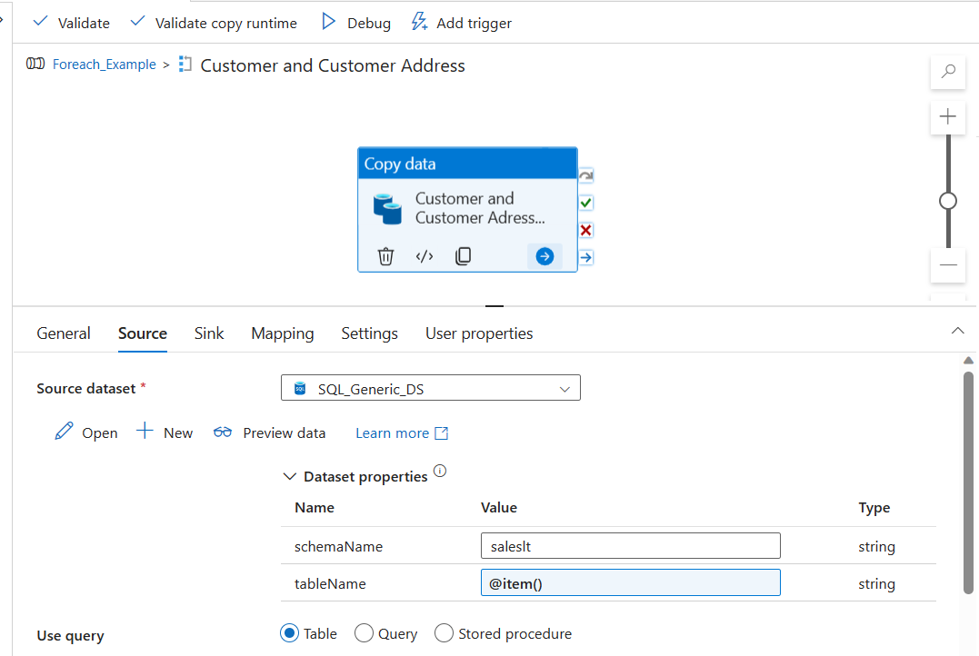

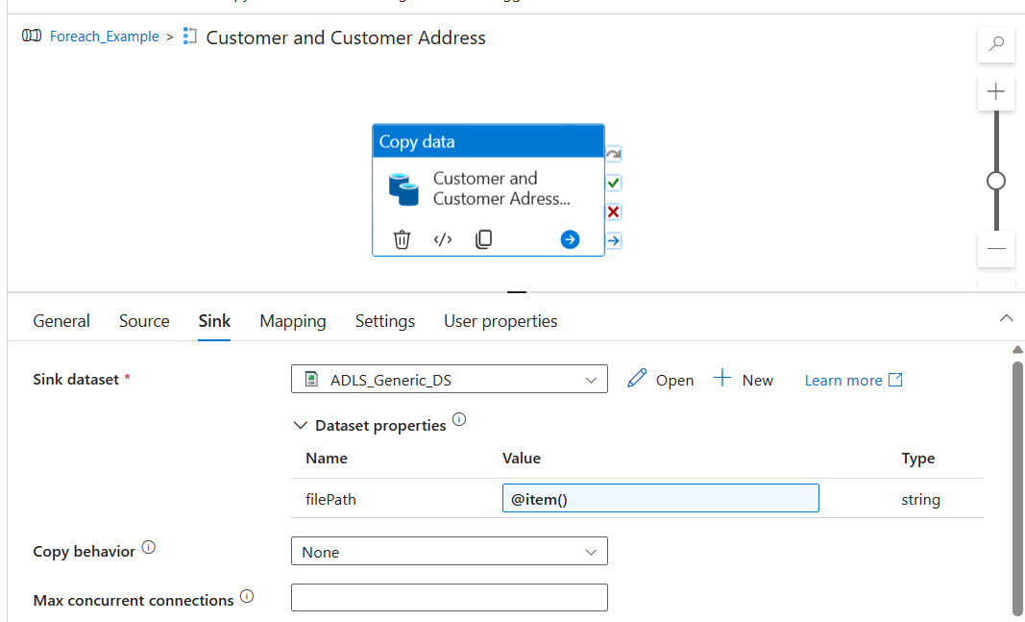

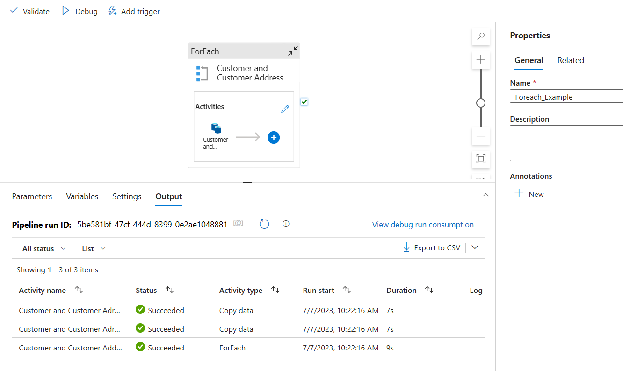

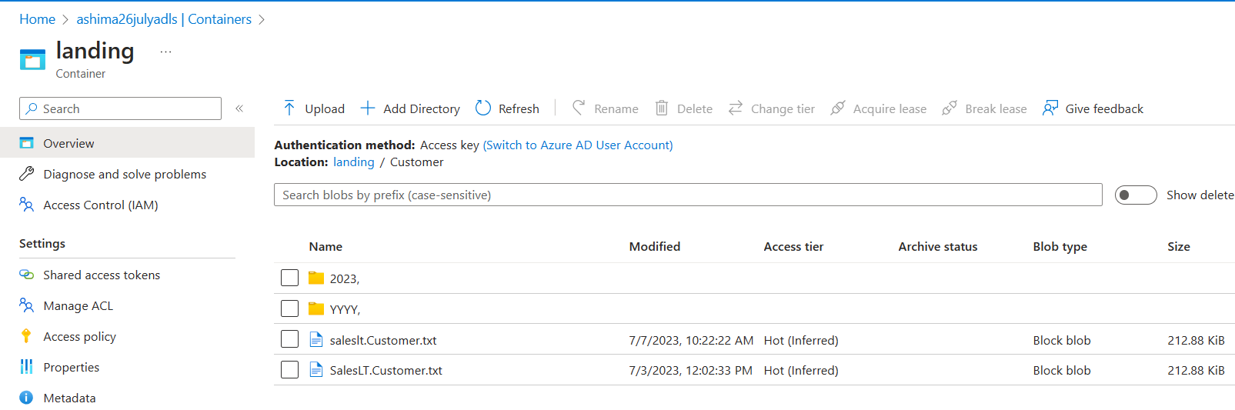

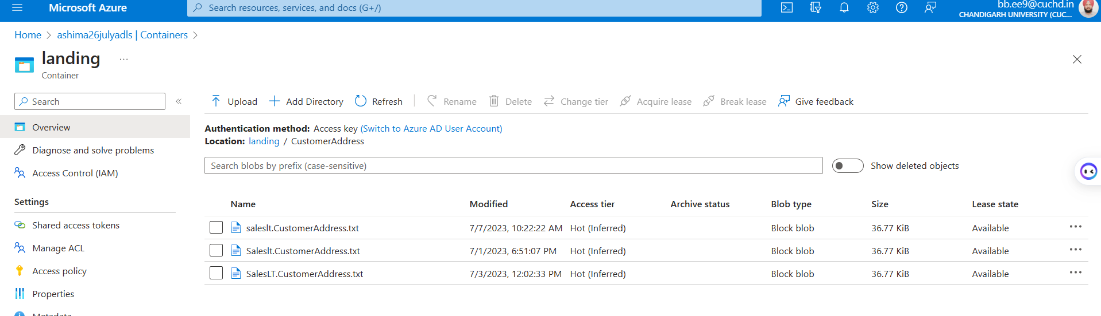

3. Create a pipeline name 'Foreach_Example_2' which solves the following business use case.

Customer data is very important for our business. Hence whenever we have more than 100 records in the customer table,we copy the customer data to another table customer_copy within the sql db.

However whenever we do this copy, we first truncate the table 'customer_copy' and then copy the data from 'customer' table.

Hint : Use ADF to solve this problem.

**Solution : To clone an Azure SQL Database table, we can use the following steps:**

1. **Connect to Azure SQL Database.**
2. **Open a new query window and execute the following SQL statement to create a new table with the same structure as the source table:**

**CREATE TABLE SalesLT.Customer_Copy**

**AS**

**SELECT \***

**FROM SalesLT.Customer**

**WHERE 1=0;**

**The condition 1=0 is used in the CREATE TABLE statement with a SELECT statement to create an empty table with the same structure as the source table.**

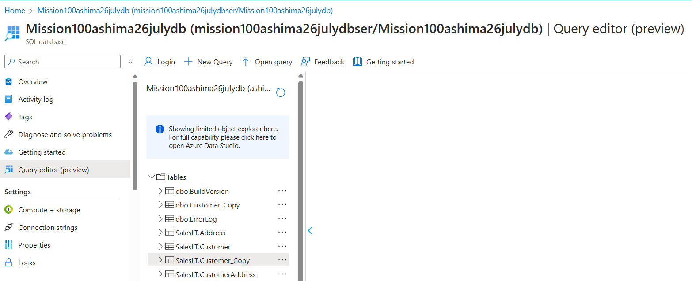

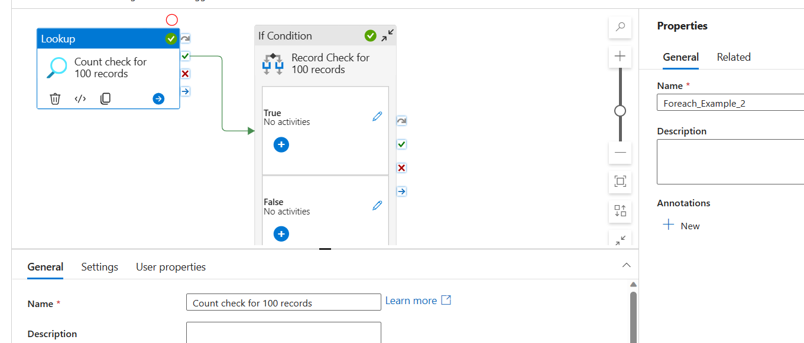

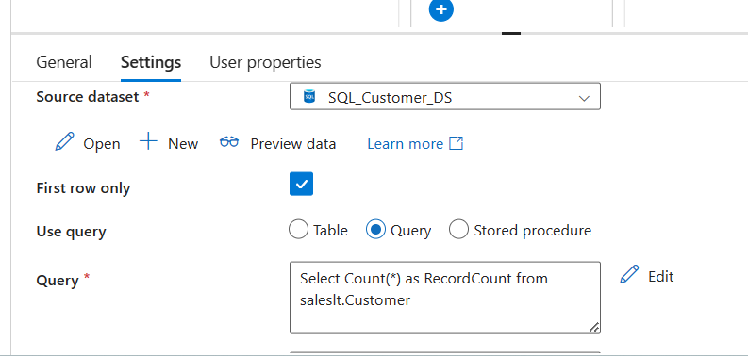

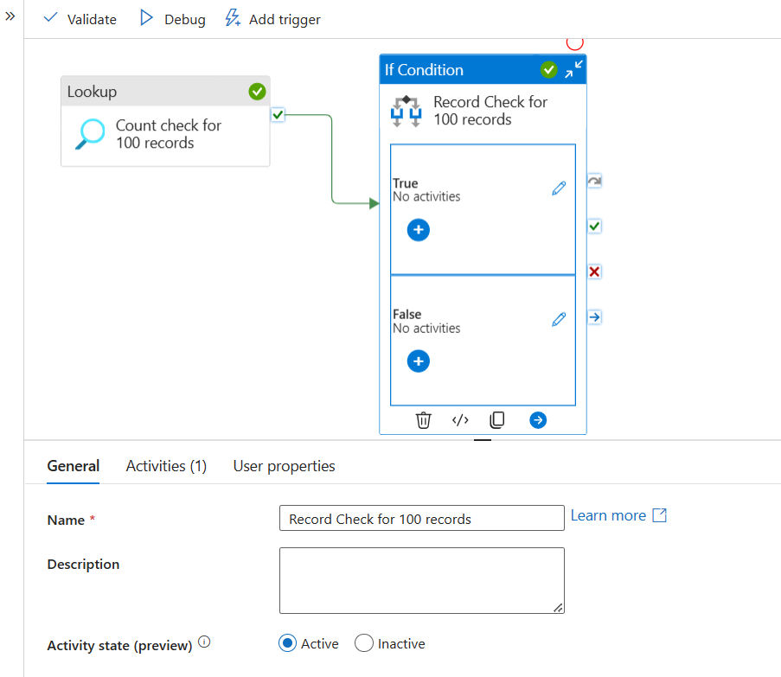

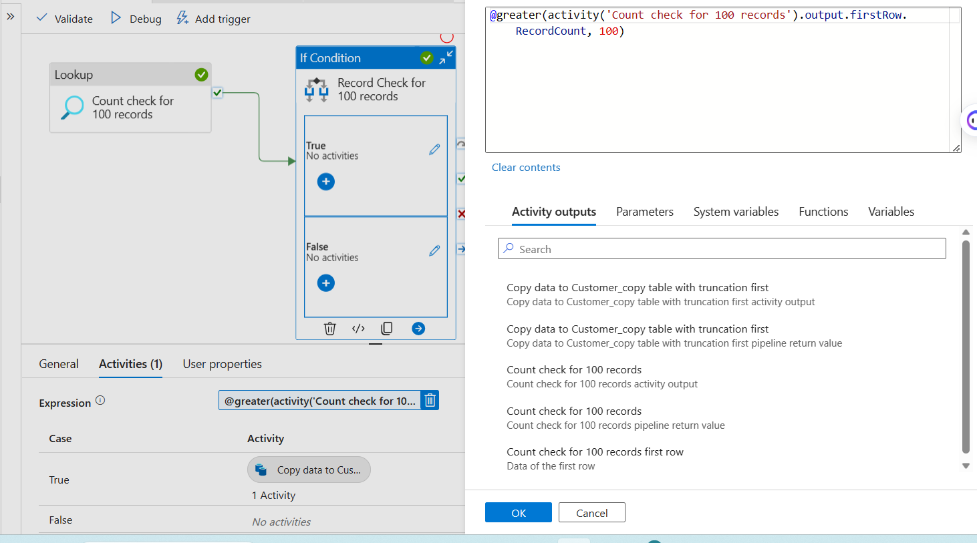

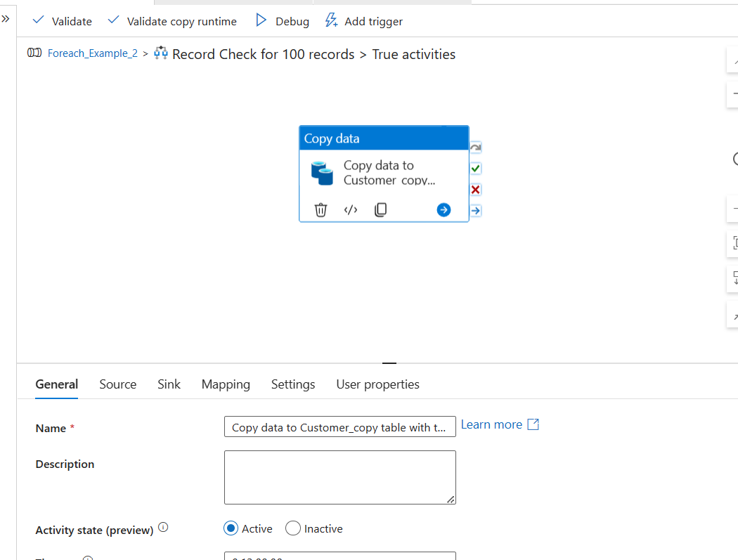

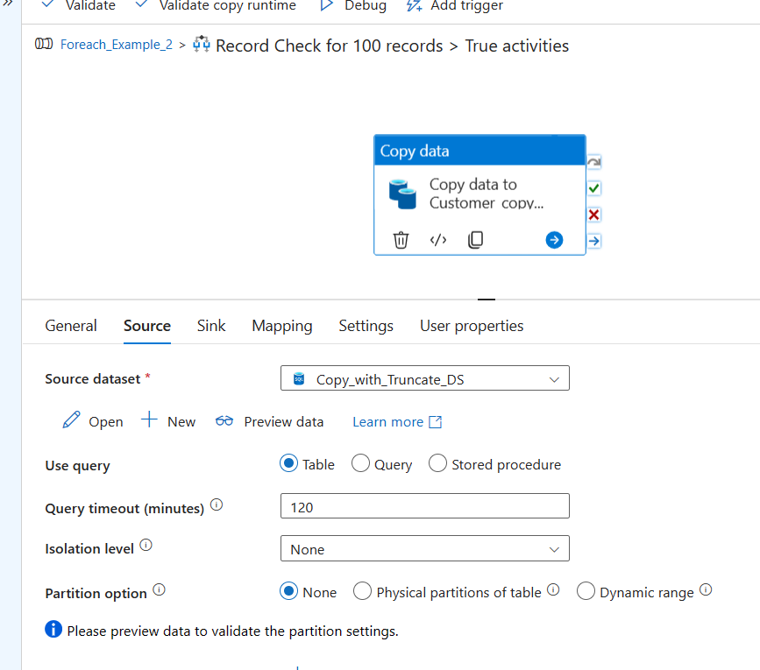

Important Link: [How to truncate table before copy in Azure data factory (azurelib.com)](https://azurelib.com/truncate-table-before-copy/)

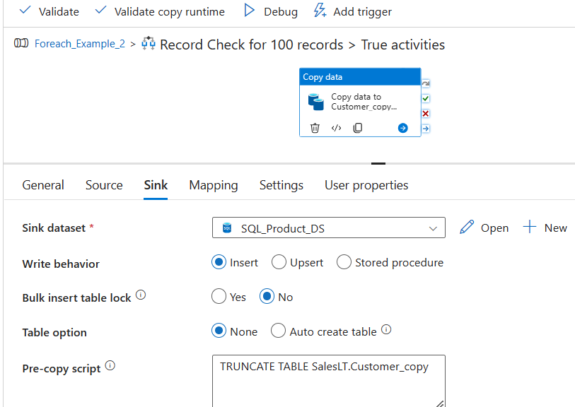

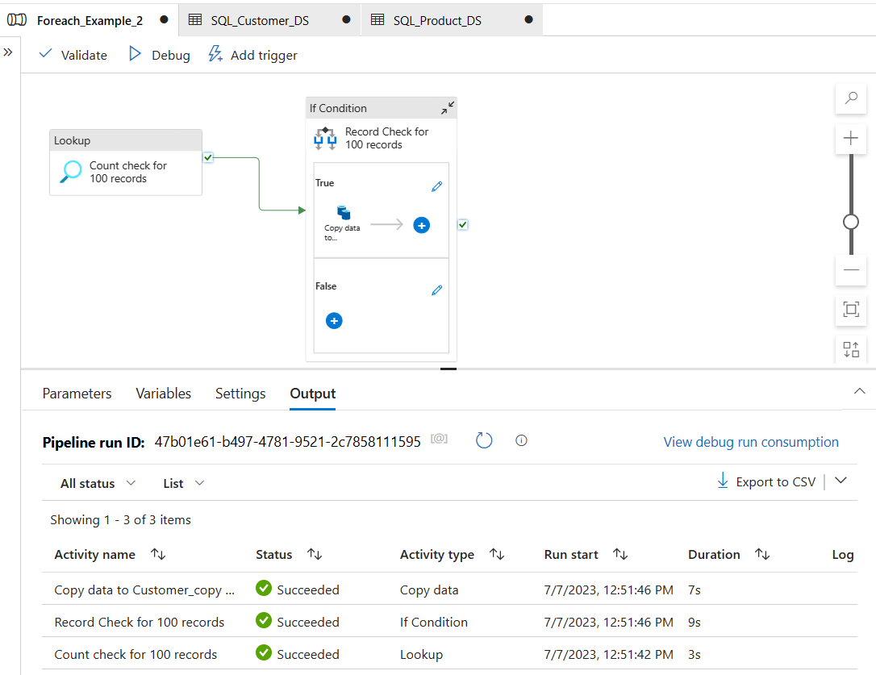

## 4. Business wants to move the data from 3 different tables (Customer, Product, CustomerAddress) to ADLS location in CSV format. However they want the make a pipeline in such a manner that All these copy happens through an individual pipeline, which is called by one common pipeline.

## (Below method shows for a Single Pipeline, for individual pipeline see next section)

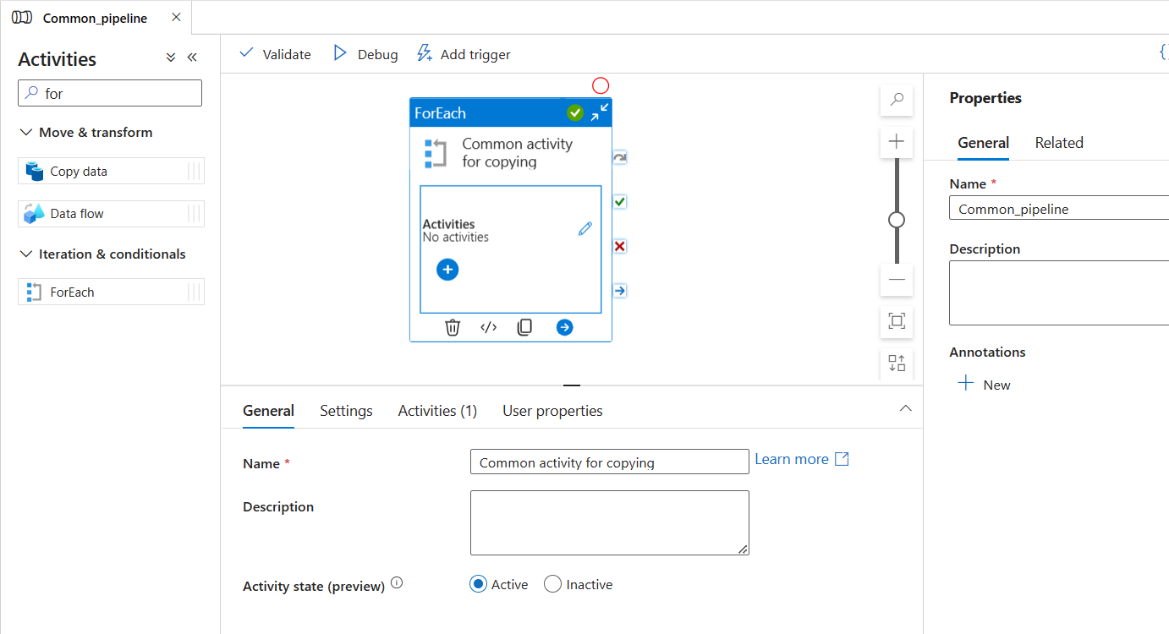

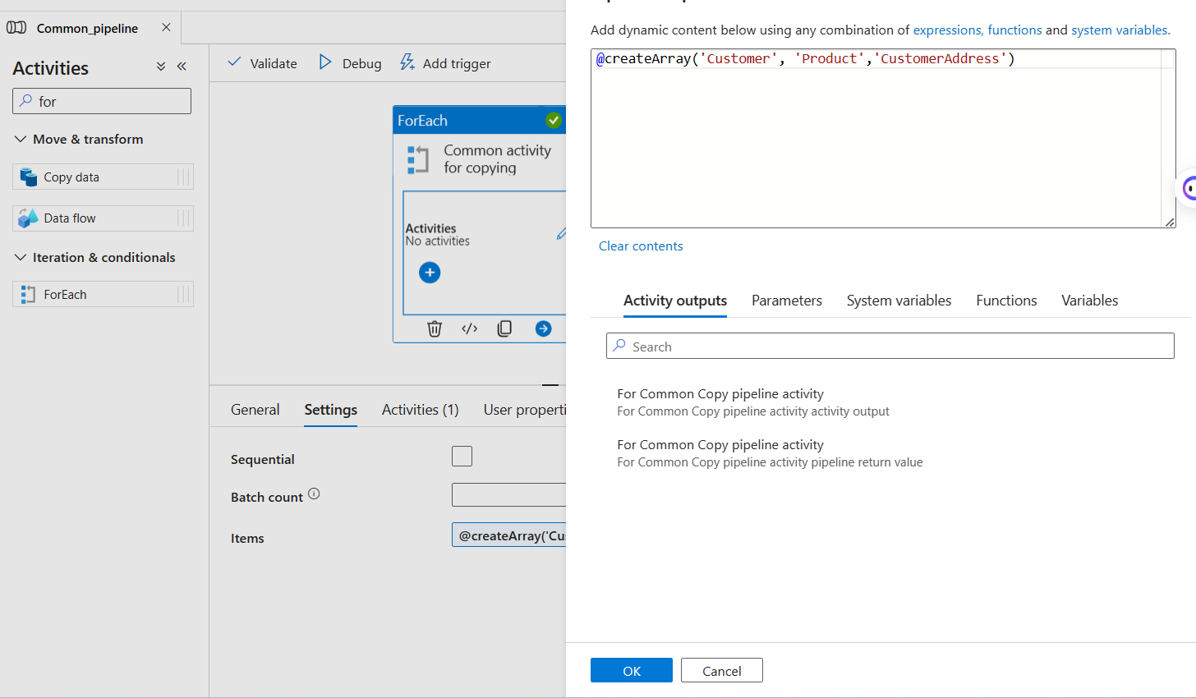

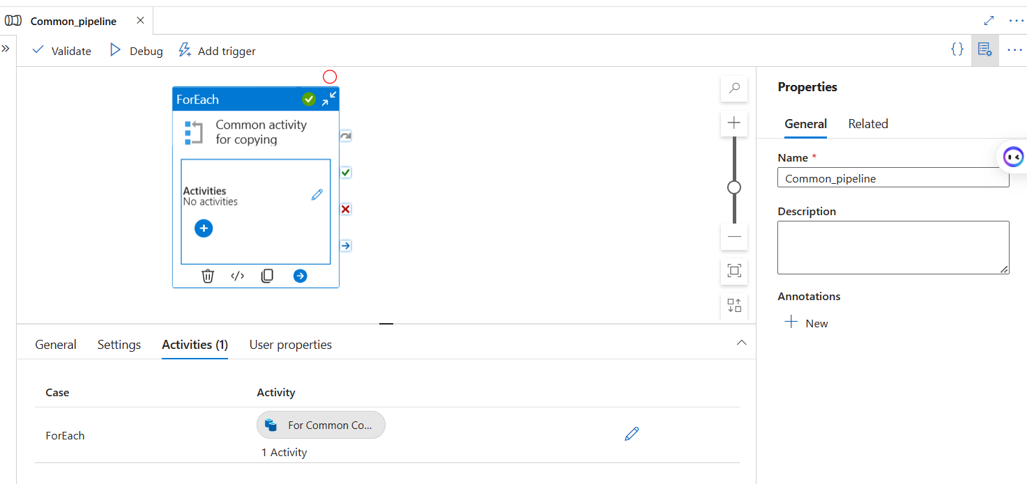

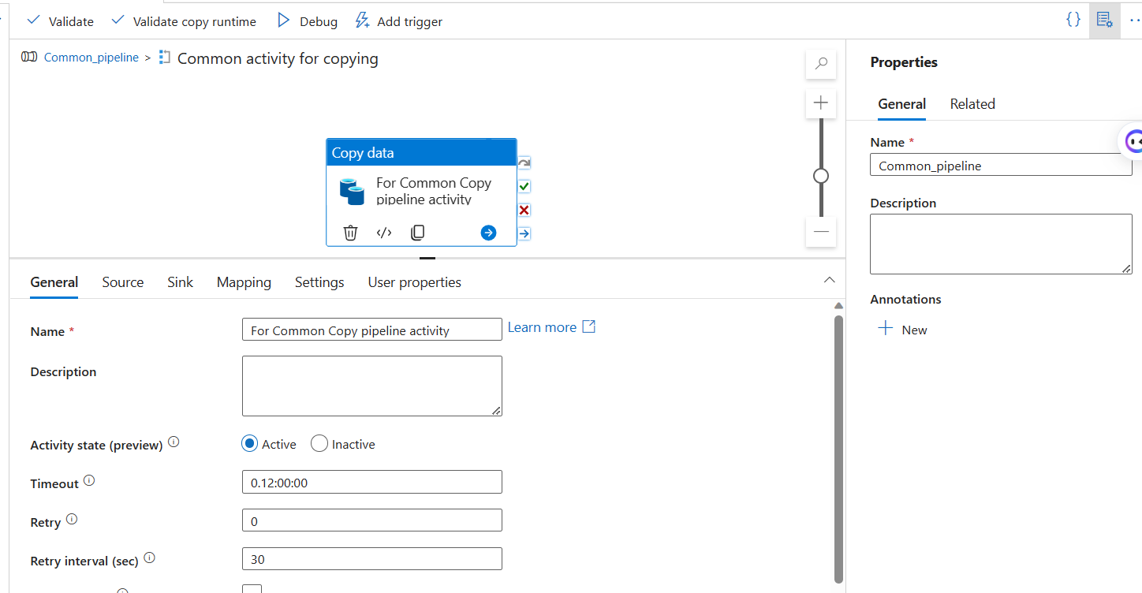

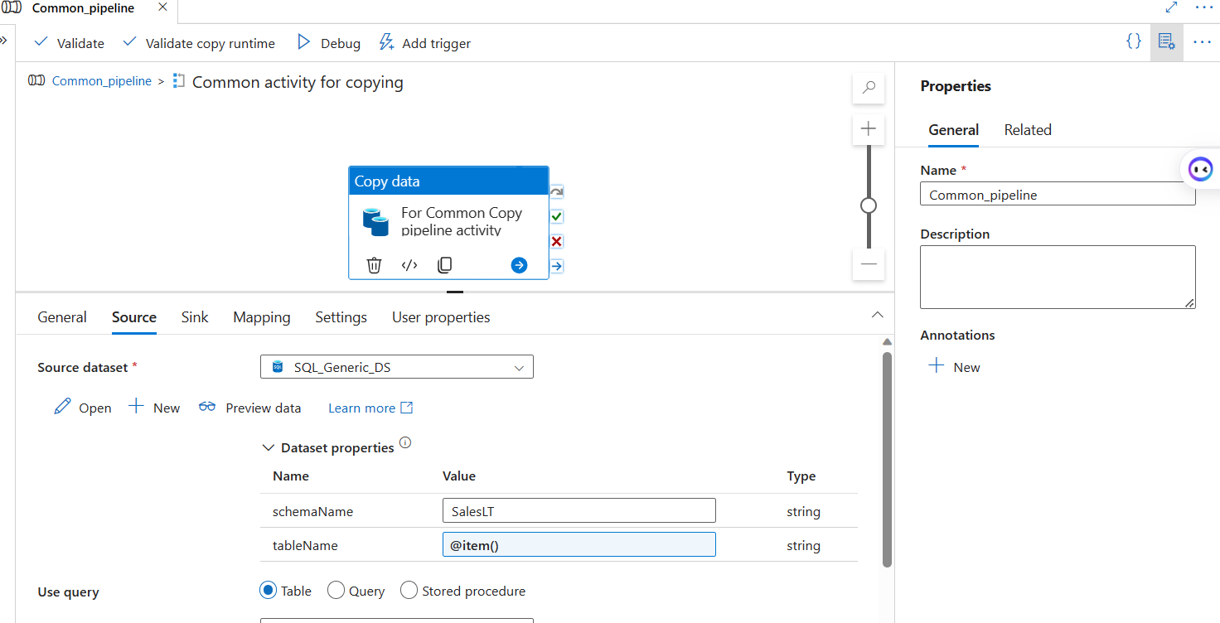

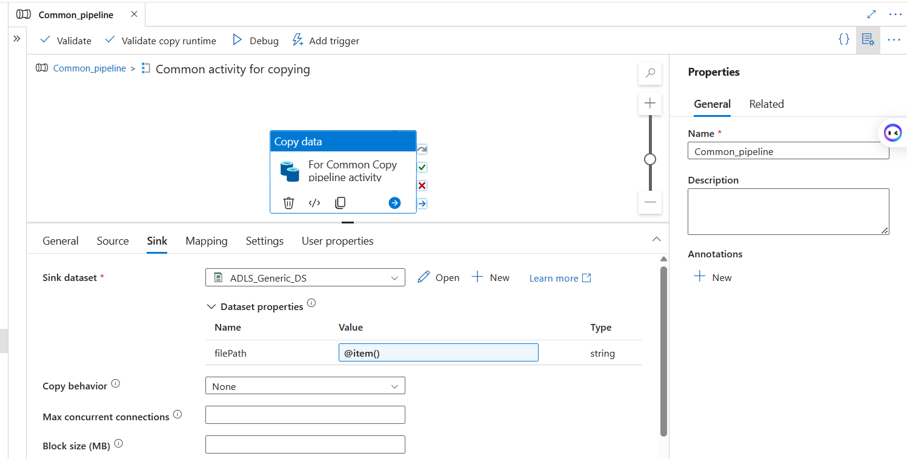

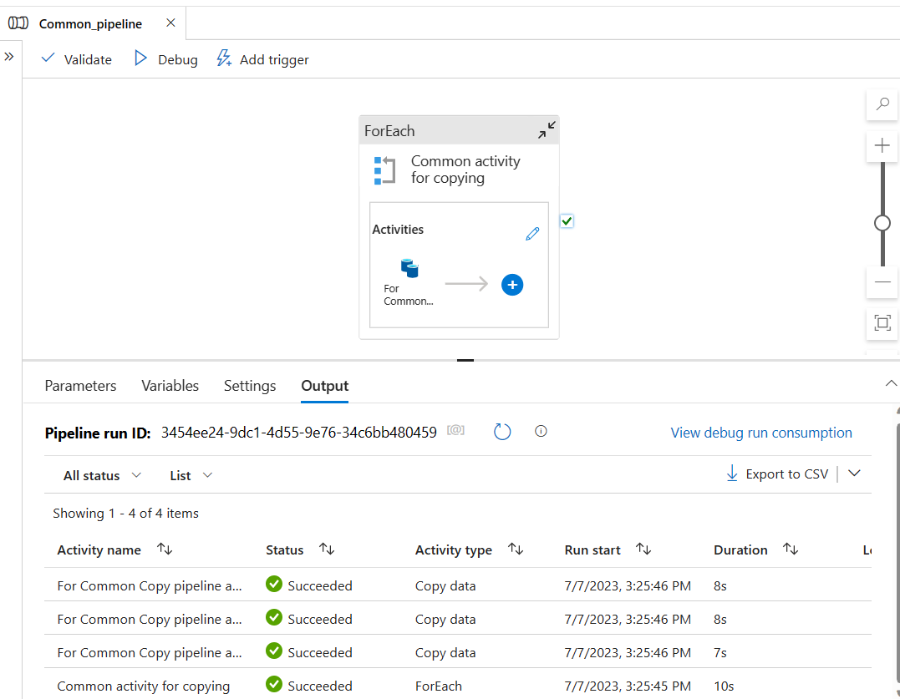

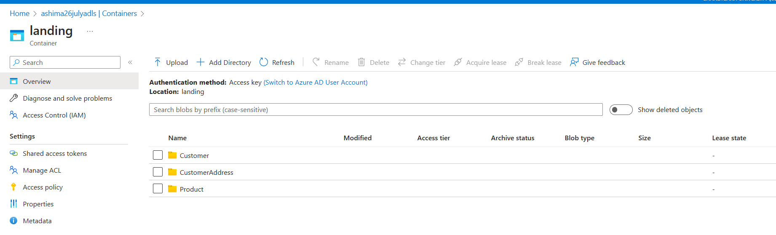

**(For Individual to common pipeline)**

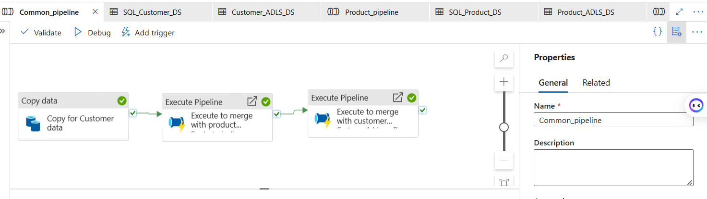

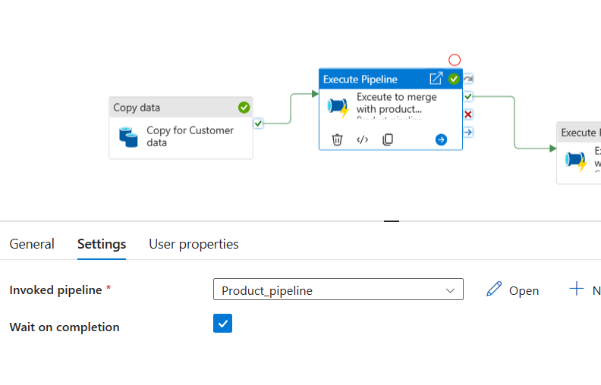

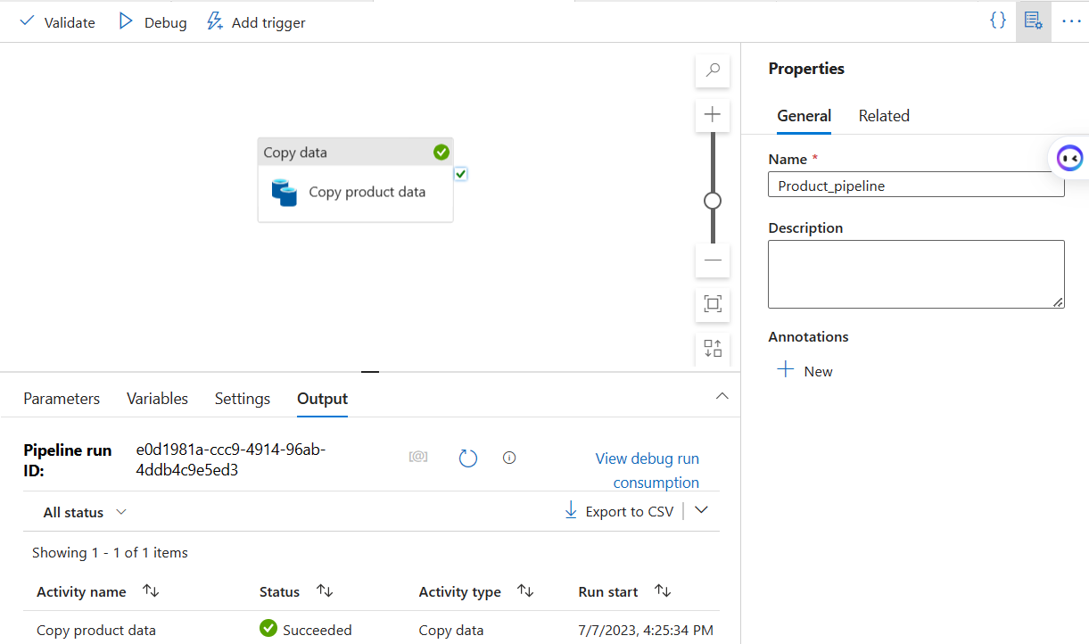

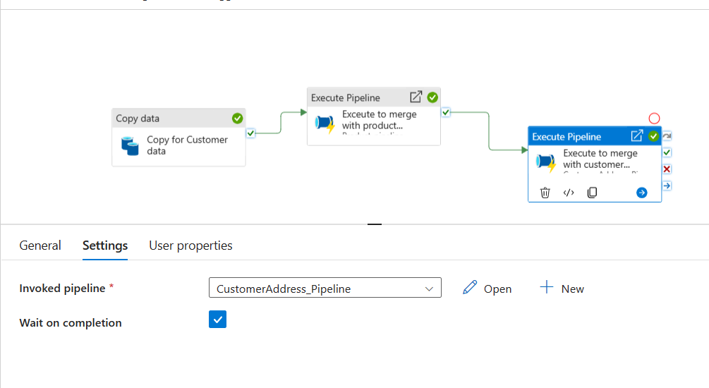

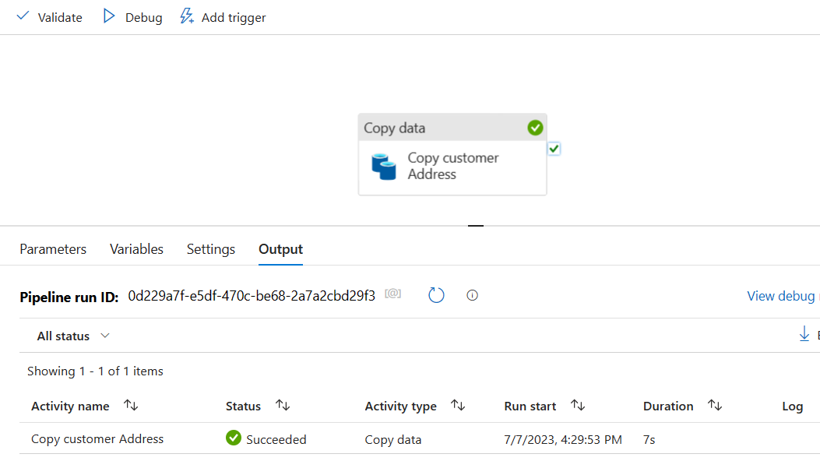

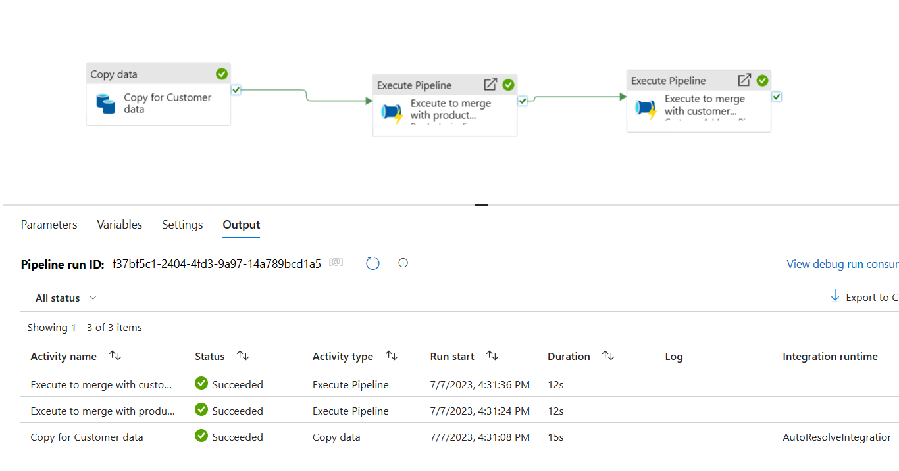

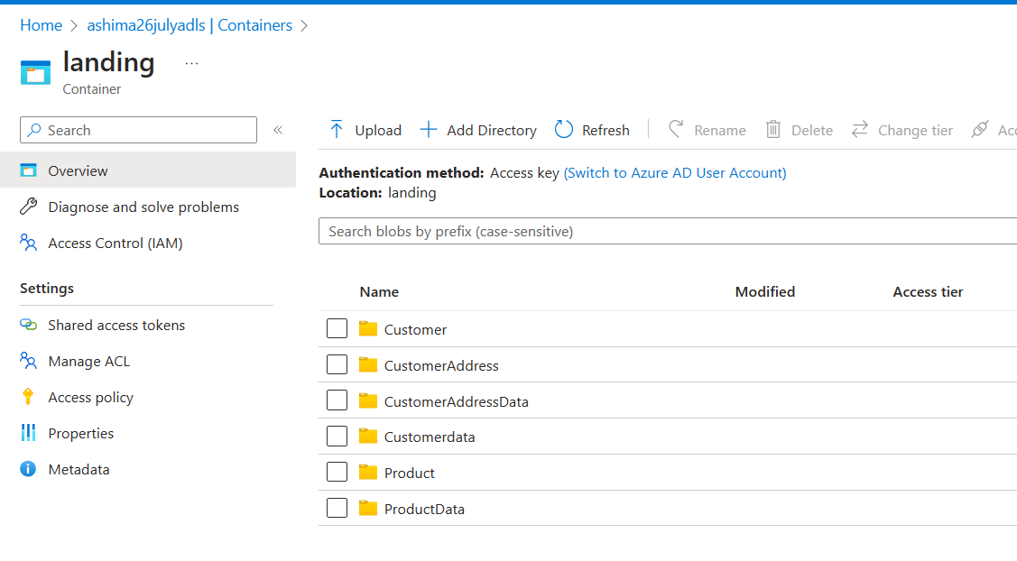

## 5. In the above case problem is that every time the pipeline runs it will overwrite the data. Ensure that all the data goes into Folder like (Customer/Year/Month/Day) to avoid any overwriting. Please rewrite the pipeline.

## 

## 

## 